

Pat a Cake Doctor Foster

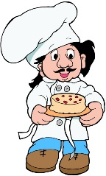Pat a cake, Pat a cake, baker's man Doctor Foster went to Gloucester  
Bake me a cake as fast as you can;  In a shower of rain;  
Pat it and prick it and mark it with a 'B',  He stepped in a puddle,  
And put it in the oven for Baby and me. Right up to his middle,   
 And never went there again!

Miss Polly Had A Dolly The Dentist’s Song

Miss Polly has a dolly who was sick, sick, sick Brush, brush, brush your teeth

So she called for the doctor to be quick, quick, quick. Keep them clean each day

The doctor came with his bag and his hat, Then you’ll have a pretty smile

And he knocked on the door with a rat-a-tat-tat. And healthy teeth all day!



He looked at the dolly and he shook his head,

And he said, “Miss Polly put her straight to bed!”

He wrote on his paper for a pill, pill, pill,

“I’ll be back in the morning yes I will, will, will!”

What is my job? Five Little Monkeys

What is my job? Five little monkeys jumping on the bed

What is my job? One fell off and bumped his head

Can you guess? Mummy called the doctor and the doctor said

Can you guess? “No more monkeys jumping on the bed!”

I help people get well Four little monkeys…

I help people get well Three little monkeys…

Who am I? Two little monkeys…

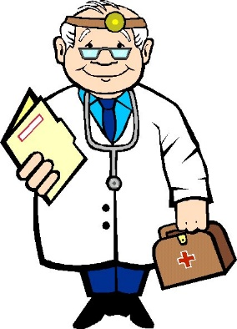Who am I? One little monkey…

(I deliver letters/I can teach you new things/

I can put out fires/I can bring you fresh milk)

Head Shoulders, Knees and Toes

Head, shoulders, knees and toes, knees and toes  
Head, shoulders, knees and toes, knees and toes  
And eyes and ears and mouth and nose,   
Head, shoulders, knees and toes, knees and toes